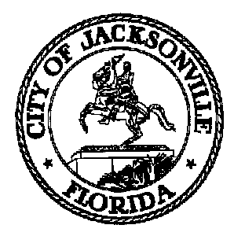
Taxation, Revenue and Utilization of
Expenditures (TRUE) Commission

Dr. Keshan Hargrove - Chair
Charles Barr – Vice Chair
Velma Rounsville - Secretary

AGENDA
City Council

President appointees

Charles Barr
Dr. Keshan Chambliss
Daniel Henry
Carter Jones
Anthony Zebouni

Mayoral appointees

CPAC appointees

Ramon Day
Kim Pryor
Velma Rounsville
Bruce Tyson

TRUE Commission
Suite 425, City Hall
117 W. Duval Street
Jacksonville FL 32202

904-255-5137

November 9, 2023

4:00 P.M.

- Call to order/quorum determination/excused absences

- Invited Speakers – Dustin Freeman, Chief of Procurement and Matt Lascell, Inspector
General re: 2023-20 – Procurement Code re-write

- Approval of minutes – October 5, 2023 meeting

- Public Comment

- Auditor’s Report

- Committee Reports
- Audit Committee
- Legislative Tracking Committee
- Chair’s Comments

- Old business

- New Business
- By-laws revision

- Commissioner Comments

- Next meeting –December 7, 2023: 1Cloud update – Paul Freeman, ITD

- Adjourn

Commissioners who are unable to attend the meeting are requested to e-mail or call the commission staff prior to the meeting to request an excused absence.

Committee Meetings
Audit Committee – Chair’s call
Legislative Tracking Committee – Chair’s call

